CLASSIFICATION OF FLOWER SPECIES

Submitted By:

Aarthi Shunmugam

**ABSTRACT:**

This Paper aims at classification of flower images by means of Gist descriptor and statistical features using SVM classifier. With advances in digital image processing, automated classification of flower images over large categories of dataset is possible by knowing the name of the flower. In case of unknown species name, classification of flower image can be performed by its visual content. The purpose of the paper is to identify different species of flower with the help of visual content. Here hundred and two categories of flower dataset are used and it is obtained from Visual Geometry Group, university of Oxford. In this paper ten classes are taken from dataset and classified. The Gist descriptor is combined with statistical features such as mean, standard deviation, skewness, Kurtosis are given to SVM classifier. It uses multiple kernel frame work to classify the images. The recognition rate is 79.36%.

**OBJECTIVE:**

The aim of the paper is to develop a framework that can be applied to the task of flower classification and can be easily extended to other similar classification tasks, i.e. classification of a large number of similar objects which require specialist knowledge.

1. **INTRODUCTION:**

The demand for medicinal plants [1] has increased over the past two decades as herbal medicines are being used widely in traditional medical systems in developed and developing countries. Wrong identification of medicinal plants is one of the factors that make herbal remedy unsafe. Owing to the ignorance of the exact identities of plants used in ayurvedic practice, many exotics are being used mistakenly or as substitutes in the absence of the plants originally recommended. Identifying a flower using a field guide or key without expert guidance is also a time-consuming task. Furthermore, the fact that some of the flowers being relatively similar and different examples of the same flower differ in colour and shape implies that the recognition by laypersons or pattern recognition systems is not straightforward. Flower classification [2] is a challenging problem within the field of computer vision that has seen much progress recently**.**

Given an image of a flower, the task is to assign a species label to the image. It is done by analysing the visual content of the image. Not all species of flowers can be distinguished visually; hence this paper will limit to ones that can be distinguished. The main problem for an object recognition system for any task is to be unaffected by irrelevant variations in the appearance of the object. For object classification, including flower classification, these appearance variations can be due to variations in imaging conditions, object deformations and variations between different object instances of a category.

**2. PROPOSED METHODOLOGY**

The proposed methodology has three major categories. Segmentation, Feature extraction and Classification.

**BLOCK DIAGRAM:**

**Fractal features**-fractal dimension, SFTA, lacunarity.

**Texture features**-energy, contrast, correlation, homogeneity.

**Gist descriptor, Ring projection**

**Statistical features**-mean, standard deviation, skewness, kurtosis.

**Region of interest**

**Training image**

**Training image**

**SVM Classifier**

**Fractal features**-fractal dimension, SFTA, lacunarity.

**Texture features**-energy, contrast, correlation, homogeneity.

**Gist descriptor, Ring projection**

**Statistical feature**-mean, standard deviation, skewness, kurtosis.

**Region of interest**

**Region of interest**

**Test image**

**Classified image**

**Classified image**

**SVM Classifier**

**Fractal features**-fractal dimension, SFTA, lacunarity.

**Texture features**-energy, contrast, correlation, homogeneity.

**Gist descriptor, Ring projection**

**Statistical feature**-mean, standard deviation, skewness, kurtosis.

**REGION OF INTEREST EXTRACTION:**

Thresholding algorithm is used for foreground and background separation. The original image is converted into HSV plane. Threshold is determined by calculating the sum of mean and standard deviation of the intensity plane. Now, the image gets split into foreground and background. Region of interest will be in white colour and background will be in black colour. The original image is decomposed into R, G, B components. Map the threshold image with R, G, B planes separately. Then concatenate the mapped images. The output will be region of interest with black background. Thus background clutter can be removed. Now traverse the pixel values from left side of the image and detect the nonzero pixel value. After detecting the location of nonzero pixel value, delete the traversed columns up to the detected location. Similarly, traverse it from right, top, and bottom to detect the location and delete the matrix outside the bounding box.

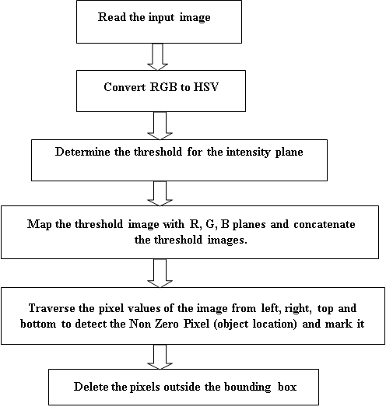

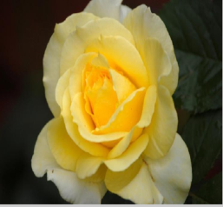 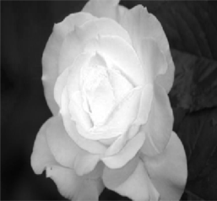 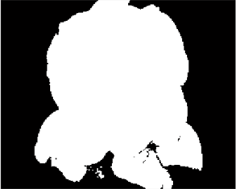

**Input Image Intensity Plane Threshold image**

 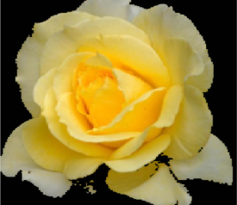

**Concatenated Image Cropped image**

**FRACTAL DIMENSION**:

Fractal dimension as an important characteristic quantity is a mathematical measure to describe the complexity of fractal sets, which have been widespread attention in theoretical research and practical applications. Fractal geometry involves various approaches to define fractional dimension, the most common of which is Hausdorff’s dimension, also known as the similarity dimension. Hausdorff’s study provided the basis for important fractal concepts.

We fill the entire area of an image F with boxes of size d. Changing the size of d means that the number of boxes N (d, F) also changes, in other words, the smaller the size of d, the greater the number of boxes. The box-counting method defines the fractal dimension of an object by the expression



**ESTIMATION OF FRACTAL DIMENSION BY BOX COUNTING METHOD**

**Input the picture after processed**

**Extraction of the image pixels in the matrix A**

**Select equal size**

M

**i=i+1**

**i<ln w/ln c**

**The matrix A is divided into the matrix that (c^i-1) ^2 sub-matrix makes up in order, calculate the nonzero sub-matrix n**

Ma

**Add the current box size and the number to the array X, Y: x=-ln(1/c^i-1); y=ln n**

**i= i +1**

**Choose position of the whole story to the array X.Y to linear regression analysis and combine into Y= bX +a , if the curve linear correlation, the slope b is the fractal dimension D**

**Output Fractal**

**GIST Descriptor:**

The inherent problems with large image databases are long access time to read all the image data. Long processing time especially with a per-pixel analysis. To avoid these kinds of problems, descriptors are used. Descriptor is a piece of stored information that is used to identify an item in an information storage and retrieval system. It saves pertinent information, saving the processing time in future queries. It can save image features that are essential for search and comparison. GIST generally means quintessence. It gives essence of an image. It was created for recognition of similar scenes, like mountains, tall buildings, streets.

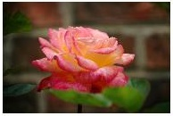 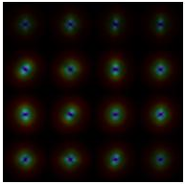

**Input image GIST Descriptor**

**Gist descriptor=n*n*k**

**Where n*n=number of Partitions**

**k=scale* orientation**

**RING PROJECTION:**

The purpose of this feature extraction is to reduce dimensionality. It matches the pattern space (such as original data) with the feature space (such as feature vectors), the dimensionality for the latter is supposed to be less than that of the former. Here we use the method of circle projection to reduce dimensionality in 2-dimpattern. First of all, the2-dim pattern can be represented by a pre-processed binary image, whose grayscale image after binary can be: [9]



1-dim pattern is rotation-invariant because bary-centric has the characteristic of rotation-invariance and the projection is carried out within concentric circles.



**Ring Projection**

**LACUNARITY:**

The concept of lacunarity was established and developed from the scientific need to analyse multi-scaling texture patterns in nature (mainly in medical and biological research), as a possibility to associate spatial patterns to several related diagnoses. Lacunarity is a powerful analytical tool as it is a multi-scalar measure, that is to say, it permits an analysis of density, packing or dispersion through scales. In the end, it is a measure of spatial heterogeneity, directly related to scale, density, emptiness and variance. It can also indicate the level of permeability in a geometrical structure.

Lacunarity measures heterogeneity to complement the fractal dimension in describing complexity. It uses pixel masses instead of box counts. In morphological analysis Lacunarity has been variously defined as gap, visual texture, non-homogeneity, translational and rotational invariance, etc. Lacunarity and fractal dimensions work together to characterize patterns extracted from digital images. Sometimes patterns having identical fractal dimensions will be distinguishable by their lacunarity, or vice versa. Lacunarity at scale *r* is defined as the mean-square deviation of the variation of mass distribution probability *Q (M, r)* divided by its square mean.

Where L(r) = lacunarity at box size *r*

M = mass or pixels of interest , Q (r, M)= probability of M in box size *r*

**GLIDING BOX ALGORITHM:**

The gliding box of a specific size (r, length of a square box) is first placed at the top left corner of an image in which each and every pixel is filled with either 1 or 0 (Allain & Cloitre, 1991; Plotnick et al., 1993).We generate binary images by converting each gray-scale image (each band) into four quartile images with value 1_s and 0_s. We basically sliced the image into five levels in order to get the four quartile images. The location of each level can be computed using the following formula:



Where l (1, . . . ,4) = location level, n = number of observations.

The digital value at the computed location for the first, second, third, and fourth levels were used as a threshold value to convert the original bands to binary images.

The gliding box is systematically moved through the binary image one pixel at a time and the box mass value is determined for each of the overlapping boxes. For lacunarity estimation of binary images, the gliding-box algorithm proposed by Allain and Cloitre (1991) and extended by Plotnick et al. (1993) is used. For a given box size r, the probability of box mass S is



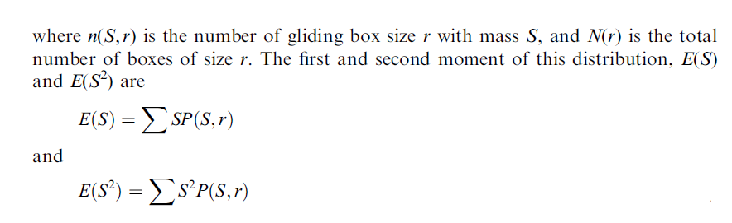

Lacunarity for gliding box size r, ᴧ(r), is defined as



Based on a random binary image which has only two values; 0 for empty and 1 for filled, it can be described as



**SFTA**

Segmentation-based Fractal Texture Analysis, or SFTA algorithm consists in decomposing the input image into a set of binary images from which the fractal dimensions of the resulting regions are computed in order to describe segmented texture patterns.

**SFTA extraction algorithm:**

After applying the Two Threshold Binary Decomposition to the input gray level image, the SFTA feature vector is constructed as the resulting binary images’ size, mean gray level and boundaries’ fractal dimension. The fractal measurements are employed to describe the boundary complexity of objects and structures segmented in the input image. The regions’ boundaries of a binary image Ib (x; y) are represented as a border image denoted by ∆(x; y) and computed as follows:



Where N8[(x; y)] is the set of pixels that are 8-connected to (x; y). ∆(x; y) takes the value 1 if the pixel at position (x; y) in the corresponding binary image Ib (x; y) has the value 1 and having at least one neighbouring pixel with value 0. Otherwise, ∆(x; y) takes the value 0. Hence, one can realize that the resulting borders are one-pixel wide. The fractal dimension D is computed from each border image using the box counting algorithm. The mean gray level and size (pixel count) complement the information extracted from each binary image without significantly increasing the computation time. Thus, the SFTA feature vector dimensionality corresponds to the number of binary images obtained by TTBD multiplied by three, since the following measurements are computed from each binary image: fractal dimension, mean gray level and size.

**TEXTURE FEATURES:**

**Contrast:**

Contrast also known as inertia is the measurement of intensity contrast or local variations between the image pixels, giving lower values for uniform texture**.**



**Correlation:**

Measures the joint probability occurrence of the specified pixel pairs.



**Energy:**

Energy also known as uniformity or the angular second moment is a way to measure disorders in an image through summing the square of all pixels, with lower values indicating a more uniform image.



**Homogeneity:**

Measures the closeness of the distribution of elements in the GLCM to the GLCM diagonal.



**STATISTICAL FEATURES:**

1. ***Mean***

The *mean* of a data set is simply the arithmetic average of the values in the set, obtained

by summing the values and dividing by the number of values. The mean is a measure of the centre of the distribution.



1. ***Standard Deviation***

The standard deviation is measures of the *spread* of the distribution about the mean.



1. ***Skewness***

Skewness is a measure of symmetry, or more precisely, the lack of symmetry. A distribution, or data set, is symmetric if it looks the same to the left and right of the centre point. Measure of Dispersion tells us about the variation of the data set. Skewness tells us about the direction of variationof the data set.



***4.Kurtosis***

**Kurtosis** is a parameter that describes the shape of a random variable’s probability distribution. Kurtosis characterizes the relative peak or flatness of a distribution compared to the normal distribution. Positive kurtosis indicates a relatively peaked distribution. Negative kurtosis indicates a relatively flat distribution.



**SVM CLASSIFIER**

Multi class SVM aims to assign labels to instances by using support vector machines, where the labels are drawn from a finite set of several elements. The dominant approach for doing so is to reduce the single multi class problem into multiple binary classification problems. Common method for such reduction include: Building binary classifiers which distinguish between (i) one of the labels and the rest (*one-versus-all*) or (ii) between every pair of classes (*one-versus-one*). Classification of new instances for the one-versus-all case is done by a winner- takes-all strategy, in which the classifier with the highest output function assigns the class (it is important that the output functions be calibrated to produce comparable scores). For the one-versus-one approach, classification is done by a max-wins voting strategy, in which every classifier assigns the instance to one of the two classes, then the vote for the assigned class is increased by one vote, and finally the class with the most votes determines the instance classification. LS-SVM classifiers (Suykens, 1999): close to Vapnik's SVM formulation but solves linear system and QP problem. SVM classifier has decrease rate of convex cost function. The Weighted Version with modified cost function was high in least square SVM classifier. It has high robustness. The original image from Oxford is resized as 256 by 256. Thirteen features are extracted from segmented image and the model is trained. Equal level of images is trained and tested for ten classes.

**SAMPLE OUTPUT:**

**FRACTAL DIMENSION:**

|  |  |  |  |  |
| --- | --- | --- | --- | --- |
| SPECIES NAME | NO.OF.IMAGE | | CLASSIFIED IMAGE | RECOGNITION  RATE |
| TRAIN | TEST |
| ROSE | 57 | 57 | 46 | 80.71 |
| PASSION FLOWER | 82 | 82 | 66 | 80.48 |
| GLOBE THISTLE | 25 | 25 | 11 | 44 |

When we included third class, the recognition rate becomes lower (from 80.59 to 68.75%). Because many flower species have same fractal dimension. Same fractal dimension occurs due to the close texture properties.

**LINEAR REGRESSION ANALYSIS:**

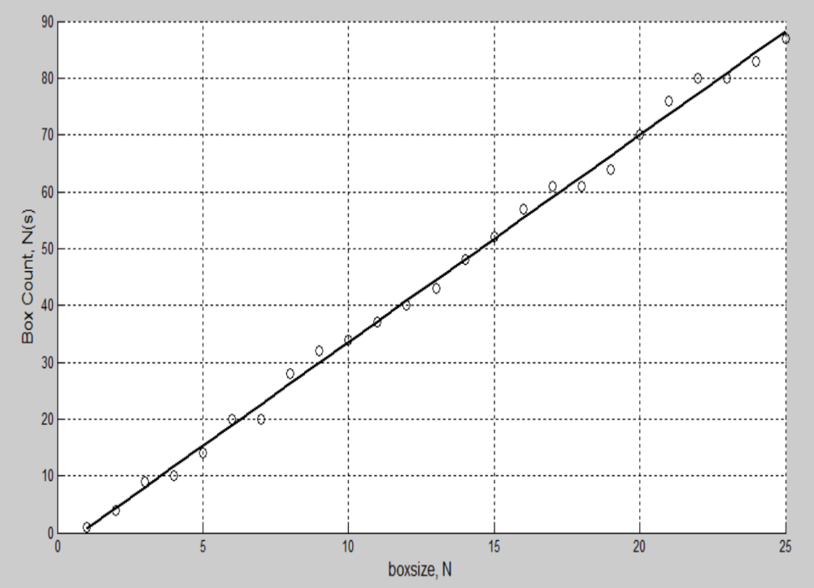

Out of all the points, the best points are selected and plotted. For this linear equation, slope is calculated. The slope is the fractal dimension.

**BEST FIT:**

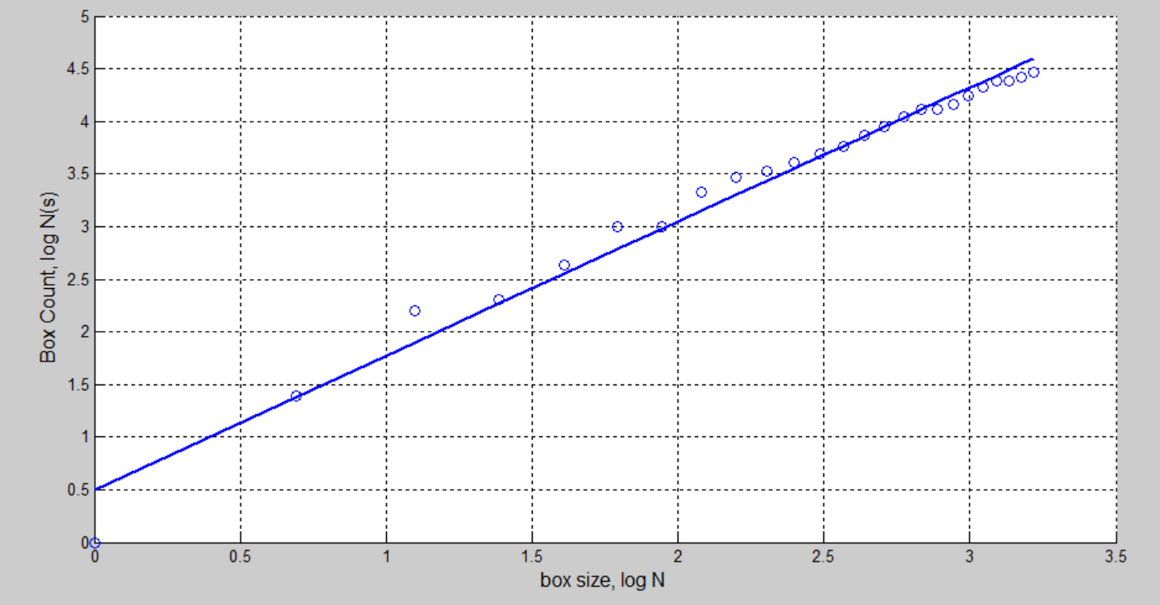

The below table gives the sample fractal dimension output for rose and buttercup flowers.

|  |  |
| --- | --- |
| **ROSE** | **BUTTER CUP** |
| 1.3702 | 1.2708 |
| 1.3349 | 1.1900 |
| 1.4018 | 1.1418 |
| 1.3274 | 1.2263 |
| 1.4158 | 1.3118 |
| 1.2268 | 1.2183 |
| 1.2865 | 1.1967 |
| 1.2790 | 1.3320 |

In order to improve classification performance, another fractal feature lacunarity is added.

For example, taking rose as input image, the output of lacunarity was 1.2337, 1.2275, 1.2201, 1.2129, 1.2105, 1.1957, and 1.0523.

**COMBINATION OF SFTA, FRACTAL DIMENSION, RING AND STATISTICAL FEATURES:**

|  |  |  |  |  |
| --- | --- | --- | --- | --- |
| SPECIES NAME | NO.OF.IMAGES | | CLASSIFIED IMAGE | RECOGNITION  RATE |
| TRAIN | TEST |
| **ROSE** | 57 | 57 | 31 | 54.38 |
| **WALL FLOWER** | 71 | 71 | 69 | 97.18 |
| **BISHOP OF LANDLAFF** | 32 | 32 | 28 | 87.5 |
| **OSTEOSPERMUM** | 21 | 21 | 16 | 76.19 |
| **BARBETON DAISY** | 44 | 44 | 27 | 61.36 |
| **GLOBE THISTLE** | 25 | 25 | 8 | 32 |
| **WATER LILLY** | 75 | 75 | 51 | 68 |
| **FRANGIPANI** | 59 | 59 | 37 | 62.71 |
| **PETUINA** | 54 | 54 | 36 | 66.66 |
| **PASSION FLOWER** | 82 | 82 | 72 | 87.80 |

**Average recognition rate is 69.37%**

While combining statistical features with fractal features, the results are improved but little only. But comparing the performance of statistical features and combination, its performance became degraded.

**TEXTURE FEATURES:**

Texture features such as contrast, energy, homogeneity and correlation are used in order to improve the recognition rate.

|  |  |  |  |  |
| --- | --- | --- | --- | --- |
| **WALL FLOWER** | 71 | 71 | 70 | 98.59 |
| **BISHOP OF LANDLAFF** | 32 | 32 | 29 | 90.62 |
| **OSTEOSPERMUM** | 21 | 21 | 13 | 61.90 |
| **BARBETON DAISY** | 44 | 44 | 26 | 59.09 |
| **GLOBE THISTLE** | 25 | 25 | 14 | 56 |
| **WATER LILLY** | 75 | 75 | 48 | 64 |
| **FRANGIPANI** | 59 | 59 | 38 | 64.4 |
| **PETUINA** | 54 | 54 | 37 | 68.51 |
| **PASSION FLOWER** | 82 | 82 | 73 | 89.02 |

**Average recognition rate is 70.65%**

While combining fractal and statistical features with texture features, it produces good results.

**COMBINATION OF GIST AND STATISTISCAL FEATURES**

|  |  |  |  |  |
| --- | --- | --- | --- | --- |
| SPECIES NAME | NO.OF.IMAGES | | CLASSIFIED IMAGE | RECOGNITION  RATE |
| TRAIN | TEST |
| **ROSE** | 57 | 57 | 36 | 63.15 |
| **WALL FLOWER** | 71 | 71 | 66 | 92.95 |
| **BISHOP OF LANDLAFF** | 32 | 32 | 26 | 81.25 |
| **OSTEOSPERMUM** | 21 | 21 | 14 | 66.66 |
| **BARBETON DAISY** | 44 | 44 | 36 | 81.81 |
| **GLOBE THISTLE** | 25 | 25 | 21 | 84 |
| **WATER LILLY** | 75 | 75 | 63 | 84 |
| **FRANGIPANI** | 59 | 59 | 42 | 71.14 |
| **PETUINA** | 54 | 54 | 43 | 79.62 |
| **PASSION FLOWER** | 82 | 82 | 73 | 89.02 |

**Average recognition rate is 79.36%**

**FINAL RESULT:**

**ALL FEATURES (Fractal Dimension, Texture, Statistical, Ring descriptor, Gist, SFTA, Lacunarity)**

|  |  |  |  |  |
| --- | --- | --- | --- | --- |
| SPECIES NAME | NO.OF.IMAGES | | CLASSIFIED IMAGE | RECOGNITION  RATE |
| TRAIN | TEST |
| **ROSE** | 57 | 57 | 41 | 71.92 |
| **WALL FLOWER** | 71 | 71 | 68 | 95.77 |
| **BISHOP OF LANDLAFF** | 32 | 32 | 29 | 90.62 |
| **OSTEOSPERMUM** | 21 | 21 | 17 | 80.62 |
| **BARBETON DAISY** | 44 | 44 | 40 | 90.90 |
| **GLOBE THISTLE** | 25 | 25 | 20 | 80 |
| **WATER LILLY** | 75 | 75 | 63 | 84 |
| **FRANGIPANI** | 59 | 59 | 52 | 88.13 |
| **PETUINA** | 54 | 54 | 45 | 83.33 |
| **PASSION FLOWER** | 82 | 82 | 76 | 92.68 |

**Average recognition rate is 85.8%**

The above table shows that when all features are combined together, recognition rate is improved a lot.

**CONCLUSION:**

This project discussed a method for classification of flower species based on fractal dimension. The flower dataset is taken from visual geometry group, University of Oxford. This project consist of three parts. Segmentation, Feature extraction and Recognition. Region of interest is extracted by means of Thresholding in order to remove the background clutter, object deformation, viewpoint variation. The original image is converted into HSV plane. Threshold is determined by calculating the sum of mean and standard deviation of the intensity plane. Features such as fractals, texture, statistical and gist descriptors are extracted from the region of interest. Fractal dimension is calculated using box counting algorithm. Lacunarity is extracted using gliding box algorithm. The experimental results show that fractal features are effective which is rotation invariant. But other features like texture, statistical and gist descriptors are needed to improve the recognition rate. Recognition is done using SVM classifier. Here multiclass LS-SVM is used which is very effective than linear SVM. This method has recognition rate of 85.8%.

**REFERENCES:**

[1] Ranga Rodrigo, Kalani Samarawickrame and Sheron Mindya,” An Intelligent Flower Analyzing System for Medicinal Plants”.

[2] M.-E. Nilsback and A. Zisserman, “An automatic visual Flora segmentation and classification of flower images”.

[3] Tzu-Hsiang Hsu & Chang-Hsing Lee & Ling-Hwei Chen,” An interactive flower image recognition system”, Multimode Tools Appl (2011) 53:53–73

DOI 10.1007/s11042-010-0490-6

[4] T Saitoh and T Kaneko,”Automatic recognition of wild flowers ,” in15th International Conference on Pattern Recognition, 2000, pp. 507 -510 vol.2.

[5] T. Saitoh, K. Aoki, and T. Kaneko. Automatic recognition of blooming flowers. In Proc. ICPR, volume 1, pages 27–30, 2004

[6] M. Das, R. Manmatha, and E. M. Riseman. Indexing flower patent images using domain knowledge. IEEE Intelligent Systems, 14(5):24–33, 1999.

[7] M.-E. Nilsback and A. Zisserman. Delving into the whorl of flower segmentation. In Proc. BMVC., volume 1, pages 570–579, 2007.

[8] M.-E. Nilsback and A. Zisserman. A visual vocabulary for flower classification. In Proc. CVPR, volume 2, pages 1447–1454, 2006.

[9] Ji-xiang Dun, Chuan-MinZhai,Qing-PingWang,” Recognition of plant leaf image based on fractal dimension features “ Elsevier Neurocomputing 116 (2013) 150–156,2012.

[10] Gurupjit Singh Brar and Amandeep Kaur, “Analysis ofRotation Invariant Template Matching Techniques for Trademarks” In proc IJERA,Vol. 2, Issue 5, September- October 2012, pp.1742-1747.

[11] Christopher J.C. Burges,”A tutorial on Support vector machines for Pattern recognition” Kluwer Academic Publishers, Boston.

[12] Yuning Chai,” Recognition between a Large Number of Flower Species”, Master Thesis

Swiss Federal institute of Technology, Zurich.

[13] Ivan Sikiri´c and Karla Brki´c, Siniša Šegvi´c, ”Classifying traffic scenes using gist image descriptor “ in Proceedings of the Croatian Computer Vision Workshop, Year 1, September 19, 2013, Zagreb, Croatia.

[14] Charles et al,” An efficient implementation of the gliding box lacunarity algorithm”, Elsevier, Nonlinear phenomena, volume 237, issue 3, March 2008, pages 306-315.

[15] M. N. Barros Filho a, F. J. A. Sobreira b,”Accuracy of lacunarity algorithms in texture classification of high spatial resolution images from urban areas”, In proc ISPRS, XXXVII/congress.

[16] Alceu costa,” An Efficient algorithm for Fractal Analysis of Texture”, ieeexplore.ieee.org/xpls/abs_all.jsp?arnumber=6382737

[17] Home pages.inf.ed.ac.uk/rbf/HIPR2/classify.htm.

[18] Wacker, A.G and Landgrade, D.A., ”Minimum distance classification in Remote sensing”, LARS Technical Reports, Paper 25.

[19] en.wikipedia.org/ wiki/support vector Machine.

[20] Yuan Y. Tang, Yu Tao*∗*, Ernest C.M. Lam,” New method for feature extraction based on fractal behavior”, Pattern Recognition 35 (2002) 1071–1081.

[21] Jieping Ye et al,” SVM versus Least Squares SVM”, jmlr.org/proceedings/papers/v2/ye07a/ye07a

[22] Johan Suykens,” Support vector machines and kernel methods in

systems, modeling and control”, http://www.esat.kuleuven.be/scd/

[23] Maria-Elena Nilsback and Andrew Zisserman,” Automated flower classification over a large number of classes, ieeexplore.ieee.org/iel5/4756033/4756034/04756141.

[24] Erkan tanyildizi,” Color texture image classification based on fractal features and extreme learning machine” online.journals.tubitak.gov.tr/openAcceptedDocument.htm.

[25] P. Zhang, T.D.Bui, C.Y.Suen,”Recognition of Similar Objects Using 2-D Wavelet-Fractal Feature Extraction, ieeexplore.ieee.org/xpl/articleDetails.jsp?arnumber=1048303.

[26] Varma et al,”Locally Invariant Fractal Features for Statistical Texture Classification”,

ieeexplore.ieee.org/xpls/abs_all.jsp?arnumber=4408876.

[27] Nair et al,” Supervised Learning Methods for Vision Based Road Detection”, cs229.stanford.edu

[28] T. Hastie, R. Tibshirani, and J.H. Friedman. *The elements of statistical learning : data mining, inference, and prediction*. Springer, 2001.

[29] K. Huang, H. Yang, I. King, and M. R. Lyu. Learning large margin classifiers locally and globally. In *ICML*, pages 401-408, 2004.

[30] G.R.G. Lanckriet, L.E. Ghaoui, C. Bhattacharyya, and M.I. Jordan. A robust minimax

approach to classification. *Journal of Machine Learning Research*, pages 555-582, 2002.

‎